
CC-215-L: Database Systems Lab

Faculty of Computing & Information Technology

BS(IT-24)
LAB – 03 (Even)
The objective of this lab is to:
1. Previous SQL Content
2. SQL functions
3. Conversion functions
4. Regular Expressions
COURSE & LAB INSTRUCTOR: Dr. Asif Sohail
LAB TIMING : 90 MINS
TOTAL MARKS : 45
Task 01: [15 marks]
- Write the SQL Query to display Hire History for the employees like the one given. 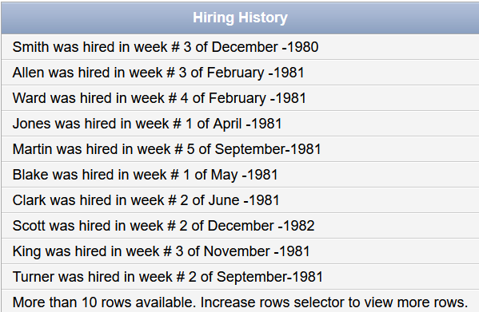
select initcap(ename) || ' was hired in week # ' || TO_CHAR(TRUNC(EXTRACT(DAY FROM HIREDATE) / 7) + 1) || ' of ' || TO_CHAR(hiredate,'Month') || ' - ' || EXTRACT(YEAR FROM HIREDATE)
AS HIRE_HISTORY FROM EMP

- Write the query to find days remaining till your next birthday and if the birthday has passed for the current year display a message like :( otherwise :)

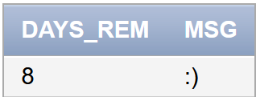
SELECT
TRUNC(TO_DATE('09-10' || '-' || TO_CHAR(EXTRACT(YEAR FROM SYSDATE)),'DD-MM-YYYY')
- TO_DATE('01-10-2025','DD-MM-YYYY')) AS DAYS_REM,

SUBSTR(' :):(', SIGN(TO_DATE('09-10' || '-' || TO_CHAR(EXTRACT(YEAR FROM SYSDATE)),'DD-MM-YYYY')
- TO_DATE('01-10-2025','DD-MM-YYYY'))*2,2) AS MSG
FROM dual;

- Display employees hired in a specific month (e.g., 'December').
SELECT ENAME, HIREDATE
FROM EMP
WHERE TO_CHAR(HIREDATE, 'Month') = 'December ';

- Display the count of A and T in the ename of employees.

select ename,
length (ename ) - length(replace(ename , 'A' , '')) "Count of A" ,
length (ename ) - length(replace(ename , 'T' , '')) "Count of T" from emp

- Write an SQL query to determine whether a student name has an even or odd number of letters. Display 'E' for even and 'O' for odd.
SELECT std_name,translate(mod(length(std_name),2),'01','EO') as len from pucit;

- Display tweets containing hashtags.
SELECT text
FROM tweets
WHERE REGEXP_LIKE(text, '#');

- Suppose that all the employees are hired on 6 months’ probation period. Write a query
to display ename, hiredate, confirmation date, sal, and comm. Display ‘Y/N’
if the comm of an employees is NULL.

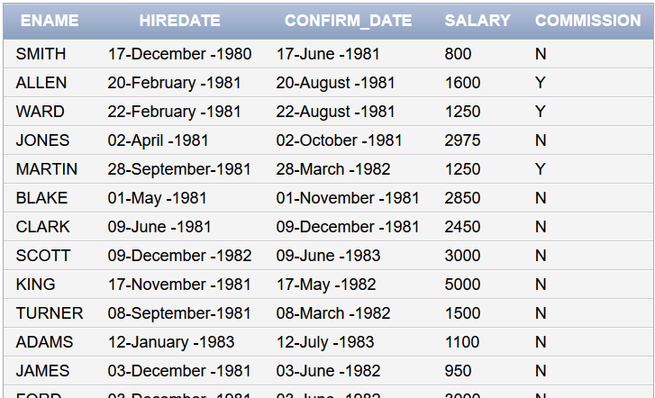
SELECT ENAME,TO_CHAR(HIREDATE,'DD-Month-YYYY')AS HIREDATE,TO_CHAR(ADD_MONTHS(HIREDATE,6),'DD-Month-YYYY') AS CONFIRM_DATE,SAL AS SALARY,

TRANSLATE(TO_CHAR(SIGN(NVL(COMM,0))),'01','NY')
AS COMMISSION FROM EMP;

- Round Salaries to nearest thousand.
select sal,round(sal,-3) from emp

- Order the employees in decreasing order of their length of names
SELECT * FROM EMP ORDER BY LENGTH(ENAME) DESC;
- Use a date function to find out first date of current year and the first date of this month.

select trunc(sysdate,'Year') date_1 ,trunc(sysdate,'Month') as date_2 from dual;

Task 02: [16 marks]
      - Display the employees who have completed an odd number of years in service.
SELECT ename, hiredate,
TRUNC(MONTHS_BETWEEN(SYSDATE, hiredate)/12) AS "Years Worked"
FROM emp
WHERE MOD(TRUNC(MONTHS_BETWEEN(SYSDATE, hiredate)/12), 2) = 1;

      - Show all employees who completed at least 10000 days in service.
select * from emp where sysdate-hiredate >= 10000;
      - Find the date of the next 5th Friday from now.
select sysdate+35 as next_friday from dual;

      - Write the query to find the texts from Tweets Having IPV6 addresses. Try to understand the pattern of IPV6 by yourself.
SELECT * FROM TWEETS WHERE REGEXP_LIKE(TEXT,'^[A-Za-z0-9].*:[A-Za-z0-9].*:[A-Za-z0-9].*:[A-Za-z0-9].*$');

      - Show employees whose names contain at least two consecutive vowels.
SELECT ename
FROM emp
WHERE REGEXP_LIKE(ename, '[AEIOUaeiou]{2}');

      - Write the query to show 1234567890 as $1,234,567,890.00
SELECT TO_CHAR(1234567890, '$9,999,999,999.00') AS FORMATTED_NUM FROM DUAL;

      - Increase the hiredate of each employee by 3 months and then display the last date of
modified date.

SELECT empno,
ename,
ADD_MONTHS(hiredate, 3) AS "After 3 Months",
LAST_DAY(ADD_MONTHS(hiredate, 3)) AS "Last Day After 3 Months"
FROM emp;

      - One of the texts contains the contact number (XXXX-XXXXXXX) in the Tweets Tables. Write the query to find such a record.
SELECT * FROM TWEETS WHERE REGEXP_LIKE(TEXT,'^.*[0-9]{4}-[0-9]{7}.*$');

      - Create a Salary Bar (Histogram) as shown. You can use the “█” symbol to create the chart. One █ = 800.
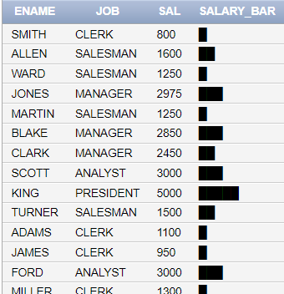
SELECT ENAME,JOB,
SAL,
RPAD(' ', SAL/800+1, '█') AS SALARY_BAR
FROM EMP;

      - Display the quarter of the year in which employee was hired (solve this question using date function only)
SELECT ENAME,
HIREDATE,
'Q' || TO_CHAR(HIREDATE,'Q') AS HIRE_QUARTER
FROM EMP;

Task 03: [9 marks]

1. Write the query to find Tanh score for every salary.
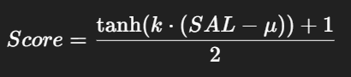
Assume k=0.01 and mean(u) = 2066.
Round the result to four decimal places.

SELECT
ENAME,
SAL,
ROUND(
(TANH(0.01 * (SAL - 2066)) + 1)/2,
4
) AS TANH_SCORE
FROM EMP;

- Prepare a report that shows:
- Employee Name,
- Current Monthly Salary,
- Projected Salary after 1 Year with 10% increase,
- Display projected salary in $ currency format with decimal like ($5.00)

SELECT ename AS "Employee",
sal AS "Current Salary",
ROUND(sal * POWER(1.10,1),2) AS "Projected Salary (1 Year)",
TO_CHAR(ROUND(sal * POWER(1.10,1),2), 'L999,999.00') AS "Formatted Projected Salary"
FROM emp;

- We need to store data in a matrix like this for every employee where each element is a scalar.
[[A] [B] [C]
[D] [E] [F]
[G] [H] [I]]
Where:
- A → 1st letter of ENAME
- B → Last letter of ENAME
- C → Length of ENAME
- D → 2-digit hire year (YY)
- E → Month of hire padded to 2 digits
- F → Day of hire padded to 2 digits
- G → DEPTNO divided by 10
- H → Number of vowels.
- I → (SAL modulo 9)

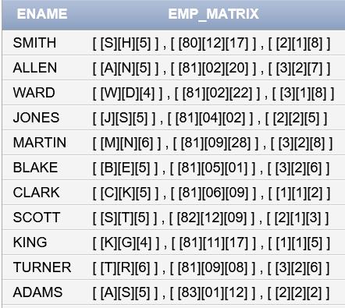

Sol 1 :
SELECT
ENAME,
'[ ' || '[' || SUBSTR(ENAME,1,1) || '][' || SUBSTR(ENAME,-1,1) || '][' || LENGTH(ENAME) || ']' || ' ] , ' ||
'[ ' || '[' || TO_CHAR(HIREDATE,'YY') || '][' || TO_CHAR(HIREDATE,'MM') || '][' || TO_CHAR(HIREDATE,'DD') || ']' || ' ] , ' ||
'[ ' || '[' || DEPTNO/10 || '][' ||
to_char(length(ename)-length(replace( replace ( replace ( replace ( replace( lower(ename),'a','' ),'e',''),'i',''),'o',''),'u',''))) || '][' ||
MOD(SAL,9) || ']' || ' ]' AS EMP_MATRIX
FROM EMP;

Sol 2 :
SELECT
ENAME,
'[ ' || '[' || SUBSTR(ENAME,1,1) || '][' || SUBSTR(ENAME,-1,1) || '][' || LENGTH(ENAME) || ']' || ' ] , ' ||
'[ ' || '[' || TO_CHAR(HIREDATE,'YY') || '][' || TO_CHAR(HIREDATE,'MM') || '][' || TO_CHAR(HIREDATE,'DD') || ']' || ' ] , ' ||
'[ ' || '[' || DEPTNO/10 || '][' ||
LENGTH(REGEXP_REPLACE(LOWER(ENAME),'[^aeiou]')) || '][' ||
MOD(SAL,9) || ']' || ' ]' AS EMP_MATRIX
FROM EMP;

Task 04: [5 marks]
VIVA VOCE

